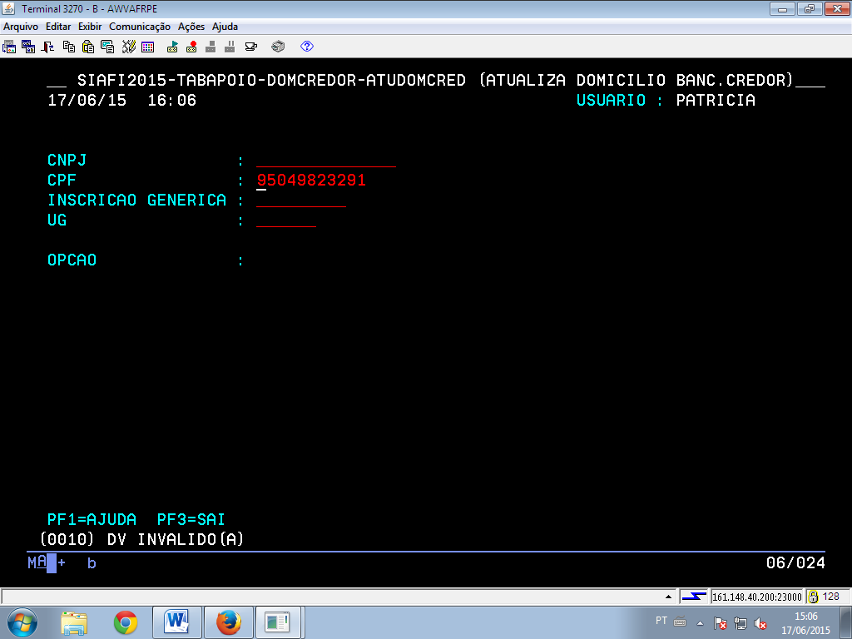
CPF: 950.498.232-91 ROBSON DA SILVA FERNANDES

